**Foundations of Computer Science – Exercise 2**

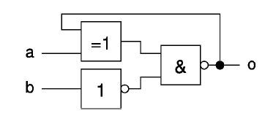2.

|  |  |  |  |  |  |
| --- | --- | --- | --- | --- | --- |
| **a** | **b** | **o *(o in)*** | **!b** | **a o** | **!b AND (a XOR o) *(o out)*** |
| 0 | 0 | 0 | 1 | 0 | 0 |
| 0 | 0 | 1 | 1 | 1 | 1 |
| 0 | 1 | 0 | 0 | 0 | 0 |
| 0 | 1 | 1 | 0 | 1 | 0 |
| 1 | 0 | 0 | 1 | 1 | 1 |
| 1 | 0 | 1 | 1 | 0 | 0 |
| 1 | 1 | 0 | 0 | 1 | 0 |
| 1 | 1 | 1 | 0 | 0 | 0 |

3.

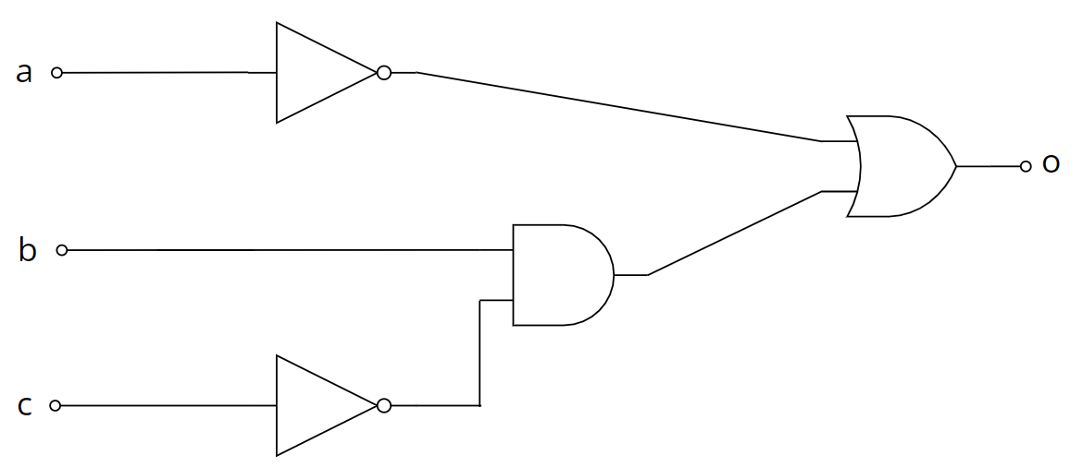o = a’b’c’ + a’b’c + a’bc’ + a’bc + abc’

= a’b’(c’ + c) + a’bc’ + a’bc + abc’

= a’b’ + a’bc’ + a’bc + abc’

= a’(b’ + bc’) + a’bc + abc’

= a’b’ + a’c’ + a’bc + abc’

= a’b’ + a’(c’ + bc) + abc’

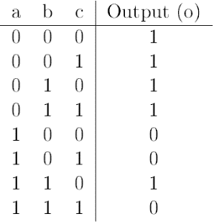= a’b’ + a’(c’ + b) + abc’

= a’b’ + a’c’ + a’b + abc’

= a’(b’+b) + a’c’ + abc’

= a’+ a’c’ + abc’

= a’+ abc’

= a’+ bc’

4. Two good sources to learn about von Neumann architecture:

* <https://www.computerscience.gcse.guru/theory/von-neumann-architecture>
* <https://www.geeksforgeeks.org/computer-organization-von-neumann-architecture/>

They are good because the cover the most fundamental topics in a compact and easy to understand manner. A good source should provide a basic but balanced grasp of the topic, in a way that students can easily remember and understand.

|  |  |  |
| --- | --- | --- |
|  | Von Neumann Architecture | Harvard Architecture |
| Bus usage | Same common bus is used for both data and instruction transfer | Separate buses are used for data and instruction transfer |
| CPU | A single memory connection is given to the CPU. CPU cannot access instructions and read/write at the same time | CPU is connected with both the data memory (RAM) and program memory (ROM), separately. CPU can access instructions and read/write at the same time |
| Clock cycle | 2 clock cycles are required to execute 1 instruction as data needs to be fed before execution | Instruction is executed in 1 clock cycle |
| Based on | Traditional: Stored-Program Concept | Modern: Havard Mark I Relay |
| Hardware | Less complicated hardware demands less space | More complicated hardware demands more space |

5.

|  |  |  |  |  |
| --- | --- | --- | --- | --- |
| **Decimal** | |  | **Binary** | |
| **A** | **B** | **A** | **B** |
| 63 | 71 | 11101 | 1011 |
| 126 | 35 | 111010 | 101 |
| 252 | 17 | ~~1110100~~ | 10 |
| ~~504~~ | 8 | 11101000 | 1 |
| ~~1008~~ | 4 | 100111111 |  |
| ~~2016~~ | 2 |  |  |
| 4032 | 1 |  |  |
| 4473 |  |  |  |